Press release March 2022
Rovema BVC 260 produces 80 stand-up paper bags per minute
The multi-talented BVC 260 offers fast and reproducible recipe change without significant loss of performance.

ROVEMA packaging machines are designed for maximum output and highest flexibility. The established BVC series represents vertical packaging machines of continuous operation and packs a wide variety of products quickly, efficiently and gently, e.g. up to 210 flat bags per minute. At the Sirha trade fair in Budapest, ROVEMA will show a BVC 260 especially for chunky products such as confectionery.
Equipped with Sense&Seal product detection, the ROVEMA BVC packs reliably and with maximum machine availability, because Sense & Seal detects product in the sealing area and protects the sealing tools and cutting knives from contamination.
ROVEMA puts a special focus on the preparation of machines and lines for future packaging tasks. The use of sustainable packaging materials and the production of different bag shapes on only one machine are standard for ROVEMA. Changeover work and set-up times are continuously optimized and also proven with demanding packaging materials. The adaptation of existing machines to new, recyclable packaging materials is usually possible for the ROVEMA BVC series without major performance losses.
At the Sirha trade fair in Hungary and WARSAW PACK in Poland, ROVEMA presents a stand-up paper bag with a large facing that can also be easily retrofitted on existing BVC machines.
In combination with the machine-compatible packaging material "Mr. Paper" from SILBO (80g/m²) with partial seal coating, up to 80 POS strong paper packs per minute are produced.
"Mr. Paper" is a fully recyclable paper packaging material for a wide range of food applications. It is based on Mondi's Advantage Kraft Plus Wet Strength paper, which features excellent machinability and high paper strength that is maintained even when exposed to moisture. The packaging material ensures good ventilation of the products. Water-based printing inks additionally increase the ecological value of the packaging.
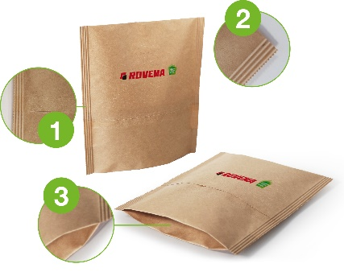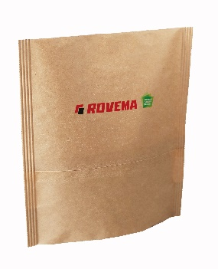
Fig.:ROVEMA SUP made of paper
1. highest seam strength with minimum packaging material consumption due to overlap seam
2. optimal seam width for your product: 5 - 14mm
3. high quality, stable bags due to sealed side gusset

With a sealing force of 6000 Newton available in the standard version, the ROVEMA BVC series offers high flexibility in the choice of packaging material - light OPP packaging materials, modern mono packaging materials, and demanding paper and laminated packaging materials can be processed. Packing material changes are quick and easy. The sealing force can be programmed as a parameter and saved as a recipe, making processes reproducible and enabling even small batches to be packaged efficiently. Ideal for the market launch of new packaging concepts.
The BVC series offers intuitive, easy-to-understand operation as well as user guidance with graphic support in the local language. Equipped with ROVEMA P@ck-Control, the BVC also ensures particularly smooth machine operation, which is achieved, for example, by adapting the movement of the sealing tools to the respective bag shape.
A wide range of equipment options allows the machine to be precisely adapted to your individual packaging task, e.g. Rovema provides for the confectionery industry:
- swiveling sealing tools for easy and ergonomic maintenance and cleaning.
- servo-motorized pre-winding with constant web tension, for a clean and even film run over the forming shoulder, especially when changing to paper packaging materials
- ultrasonic edge control for a narrow longitudinal seam that saves packaging material
- various application packages such as automatic reel change (splicer), Stabilo Seal, applicator for reclosure options or labelling systems are also available.
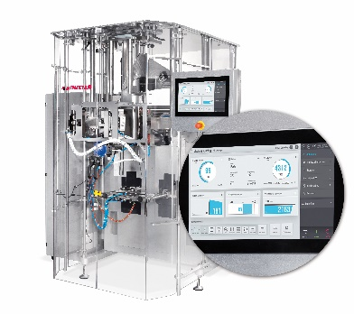
Fig: ROVEMA BVC 260, retrofittable for stand-up paper bags.
About ROVEMA:
With passion and experience of more than 60 years, ROVEMA develops and builds packaging machines and systems that meet the complex demands of the modern circular economy. ROVEMA thinks holistically and considers the environment, the market, the product and the packaging in projects from the very beginning. This enables the development of efficient and future-proof packaging machines with high availability. A sustainable solution that fits the characteristics of the product to be packaged and its requirements for logistics, packaging material, durability and energy efficiency is ROVEMA's highest priority. A successful concept - ROVEMA has already delivered more than 30,000 machines and systems worldwide.
About Silbo
Silbo is an innovative Polish producer of flexible packaging, mainly for food products. The company specializes in environmentally friendly packaging: plastic-free, compostable and made from alternative organic materials. The company has just launched "Mr Paper" packaging - fully recyclable paper packaging for food products. SILBO has over 20 years of industry experience, unique know-how and a global distribution network.
The quality of the brand is confirmed by international certificates, trusted business partners and significant customers.

