Packing liquids efficiently and sustainably June 2021
New recyclable packaging material for ROVEMA BVC 310 Liquid. With SOLOTOP PE from National Flexible, Rovema successfully tested a materially recyclable multilayer composite with EVOH barrier. The packaging material solution made of 75 µm mono-PE achieved an output of 60 pouches per minute in the application test with a heat sealing process on the ROVEMA BVC 310 Liquid machine. The output data equates to a filling quantity of 950 ccm in a flat bag with a fold-over seam (rapport length 250 mm), a typical ketchup packaging for the food service sector.
Liquid and pasty products or products preserved in oil or vinegar for the food service sector have one thing in common: They have to be transportable, storable and usable quickly, efficiently and safely.
ROVEMA as a specialist for flexible, vertically produced packaging has taken up this topic and further expanded its competence in the packaging of liquids.
The vertically continuous Form Fill and Seal machine BVC 310 Liquid is also available with a fitment option for use in portion dispensers. This hygienic product removal is essential for many system caterers. Even chunky products in brine can be packed in flat pouches in this low-air process. This application is also particularly interesting as a replacement for rigid packaging such as buckets or cans. The clear advantage of the flexible solution is lower packaging material volume and weight. This is an important factor in view of the many sustainability goals of international companies. By using flexible, low-air flow wrapping, you can optimize your packaging processes and supply chain in a future-proof way - without compromising product shelf life and quality. This is because vertical form, fill and seal machines can be quickly and flexibly adapted to changing bag lengths, fill quantities and product changes, and also have a small footprint.
If you would like to learn more about switching from rigid to flexible packaging for liquid products, we recommend our new white paper:
https://www.rovema.com/en/engineering/liquid-packaging

ROVEMA - Reduce, reuse, recycle and THINK sustainably.

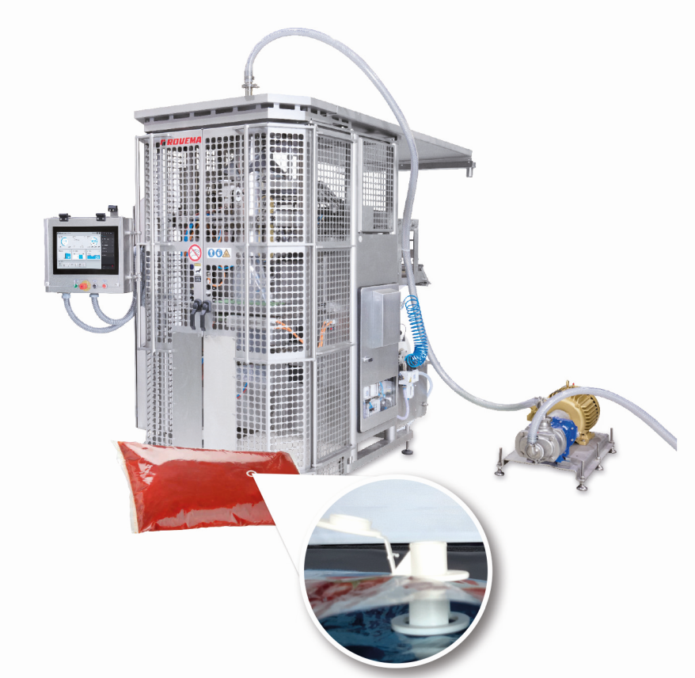
Figure: ROVEMA BVC 310 Liquid for packaging liquids. The pillow packs can also be equipped with a fitment and used in portion dispensers.

Press contact:
ROVEMA GmbH
Industriestr.1
35463 Fernwald
Nadja Richter, Marketing & Kommunikation
nadja.richter@rovema.de
Tel. 0641-409-324

About ROVEMA GmbH: With passion and the experience of more than 60 years, ROVEMA develops and builds packaging machines and lines that meet the complex demands of the modern circular economy. ROVEMA thinks holistically and considers the environment, the market, the product and the packaging in projects from the very beginning. This enables the development of efficient and sustainable packaging machines with high availability. A sustainable solution that fits the characteristics of the product to be packed and its requirements for logistics, packaging material, shelf life and energy efficiency is a top priority for ROVEMA. A successful concept - ROVEMA has already delivered more than 30,000 machines and lines worldwide. In 2020, ROVEMA generated approximately 127 million euros in sales with more than 700 employees worldwide.

