Press release July 2019

Fachpack 2019

Hall 4a / booth 411

An attractive future-proof appearance at the Point of Sale – with the Rovema BVC 260 Flexible

Rovema manufacturer of packaging machines will be exhibiting at Fachpack 2019 with sophisticated solutions for packing sweets. Main exhibit will be the continuous motion Vertical Form Fill and Seal machine BVC 260 Flexible, which has recently been awarded with Hershey’s Supplier Excellence Award for Innovation. The Rovema BVC Flexible machine series allows maximum flexibility in bag designs for bag widths up to 400 mm and is suitable for the production of Doypack-like RoPack bags with longitudinal zip. Also pillow bags, gusseted bags and 4-side-seal-pouches with or without zippers can be produced. Rovema’s BVC Flexible was developed with the goal to make a Doy-style bag on a VFFS unit as appealing as those produced by their HFFS counterparts, while offering companies the inherent advantages of VFFS machines: e.g. reduced operating cost, heightened flexibility, decreased machine footprint, quicker format changes and optional product gassing. The machine offers high efficiency compared to horizontal packaging machines - with convincing bag quality. Just product, bag shape and packaging materials limit the machine’s output rate. Depending on the specific application, up to 105 RoPack bags with longitudinal zip can be produced per minute. The Rovema BVC 260 Flexible can be optimally adjusted to various applications, such as sweets, dried fruits, cereals and nuts and processes almost all laminate packaging materials, even thinner packaging materials can be used.
The continuous motion machine is designed and built for maximum output performance. Even for the high speeds, it is equipped with product detection “Sense&Seal”. Sensitive electronics detect even tiny product parts in the sealing area, allowing the sealing process and the cutting procedure to be interrupted and the sealing jaws stopped and moved back. The machine produces a double bag that is discharged and automatically starts the packaging procedure again – cutting knife and sealing jaws remain clean. A large number of bag shapes are possible with longitudinal zip as re-closure and is supported in the process by reproducible, easy changeovers between formats. Through a variable movement pattern within the cross sealing jaws, compared to common vertical methodologies, a particularly high filling degree as well as an improved bag shaping is reached. A harmonized packaging process with smooth and even movements allows a low-wear production and a long machine service life. The product area is consequently separated from the drive area, to serve the highest hygiene requirements whilst being quick and easy to clean.

Besides the all-rounder BVC Flexible, a specialist machine will be presented – Rovema BVC 145 TwinTube succeeds as fastest twin with an output rate of up to 500 pillow bags per minute.
The ROVEMA twin tube technology allows packaging of sweets and snacks within the smallest of spaces. The continuous motion BVC 145 TwinTube is also equipped with the proven product detection Sense&Seal, which detects products in the sealed area. Defective bags are discharged directly by up to 250 bags per minute per line. Product detection works entirely independently for both lines. While discharging on line one, line two can continue production without constraints - this reduces the amount of defective bags by 50%.
A fully automatic edge control for both lines allows a reproducible format changeover. Each line has separate film drive control, which guarantees exact bag lengths. The single roll packaging material infeed is subsequently separated into two film rolls. Optionally, two film rolls can be processed separately. The sealing force of both cross sealing tools can be adjusted individually, allowing processing of various packaging materials with optimum sealed seam quality. Production of bags with euro hole is possible without a reduction of output rate.
Sophisticated and space-saving design for optimum accessibility
Machine control is fully integrated into the machine housing. The control cabinet can be pulled out completely, for easier cleaning, maintenance and adjustment processes.
Swiveling double safety doors can be fully opened and allow access to the machine’s working area. The reel carrier is also accessible from all sides. Space-saving integration of printers, labelers and metal detection is available as an option. The new ROVEMA BVC 145 TwinTube Form Fill and Seal machine sets new standards for the fast and space-saving production of perfectly shaped bags in the confectionery and snacks industry.

Your contact:  ROVEMA GmbH  Industriestr.1  35463 Fernwald | Nadja Richter  Marketing & Communication  nadja.richter@rovema.de  Phone: +49 641-409-324

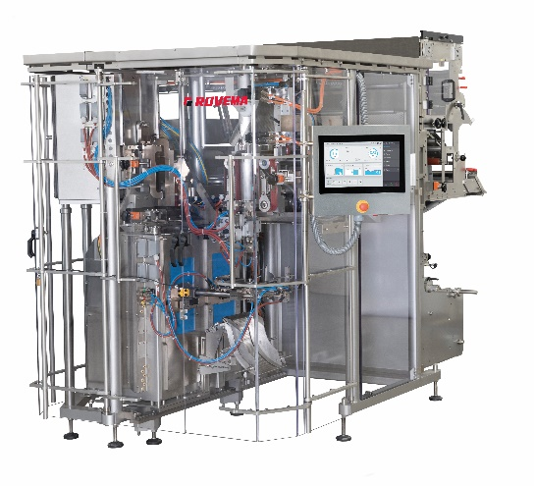
Fig. 1: Rovema BVC 260 Flexible

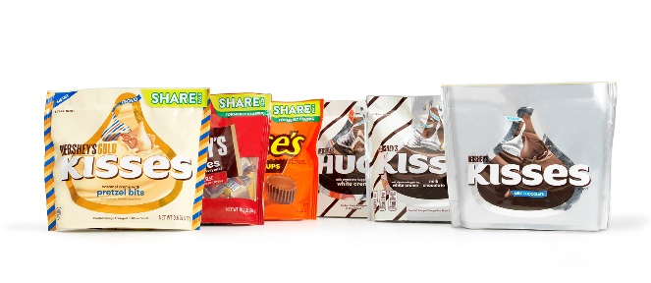
Fig. 2: Highest flexibility and future safety, awarded with the Hershey Supplier Excellence Award 2019

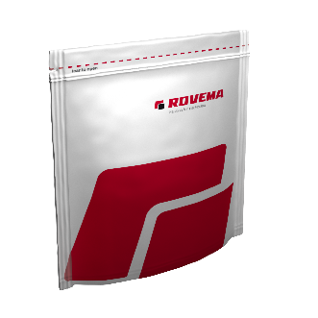
Fig. 3: Sweets and snacks vertically packed in stand-up pouches with Zip - Rovema RoPack

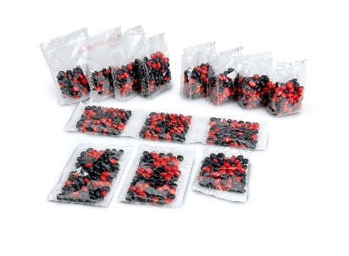
Fig. 3a: Rovema BVC 260 Flexible – bag variety

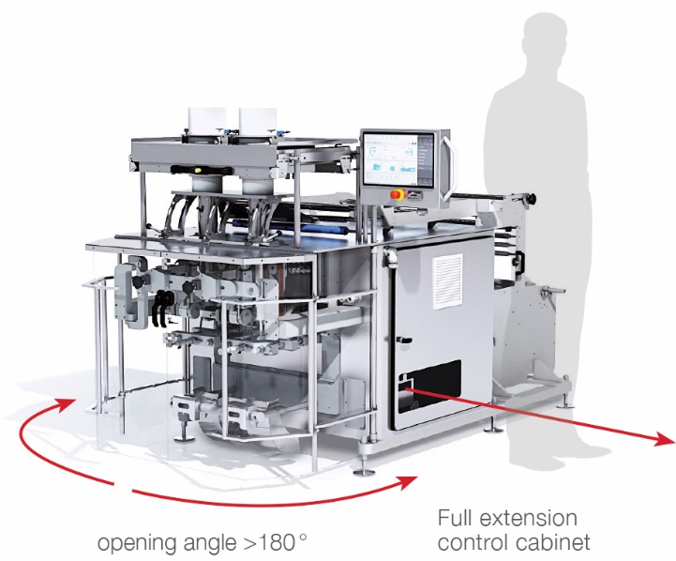
Fig.4: Rovema’s fastest twin - sophisticated and space-saving design for optimum accessibility. Footprint 4m².

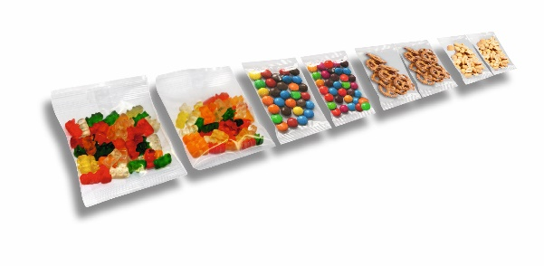
Fig. 5: ROVEMA Form Fill and Seal machine BVC 145 TwinTube: High performance for confectionery and snacks

