Press release August 2021

Fachpack 2021

Hall 4 / booth 261

More successful together: inno-tech and ROVEMA bundle capabilities for the frozen food industry.

At Fachpack 2021 Rovema will present sophisticated solutions for packaging frozen food and milling products. A continuous motion inno-tech REVO S machine and a ROVEMA SBS packaging system will be exhibited.
With the inno-tech REVO series, ROVEMA now has even more to offer the frozen food industry. The continuous Form Fill and Seal machines of the REVO series are modular and available from a simple version for small budgets up to a special machine with an inclined filling tube for the particularly gentle packaging of fragile products.
Convertible to continuous or intermittent motion packaging, the inno-tech REVO can also reliably process demanding packaging materials such as paper. The inno-tech REVO is available with Siemens or B&R machine control as standard. At Fachpack 2021, ROVEMA will showcase a pillow bag solution made of kraft paper with a water vapour barrier for the frozen food industry. A paper from Mondi that can be disposed of via the paper recycling stream is used.

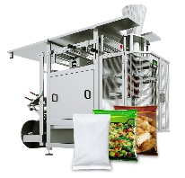
Fig 1: Form Fill and Seal machine inno-tech REVO S, specifically for the frozen food industry.

Teamwork for more sustainable solutions: ROVEMA SBS packs flour dust-free in barrier paper

Paper bags from the flat film web
With the SBS block pack machine, Rovema offers a system for low-dust, compact and dust-tight packaging of powder. Live at Fachpack 2021, compact bags filled with rice flour are produced from barrier paper. Developed specifically for applications in the food industry, SAPPI's Guard Nature 1-MS barrier paper guarantees 100 percent protection when in direct contact with dry foods such as cereals, rice, pasta or flour, and can be recycled in the paper waste stream.
The SBS block pack machine is a combination of a Form Fill and Seal machine and downstream integrated bag top and bag closure system. The block bottom bag shown is optimized in volume, which saves packing material and reduces transport volume.

Flexible, efficient and economical
The SBS block pack machine offers maximum flexibility, even for batches of different bag sizes, in addition to the many options for bag top and bag closure design. The machine is equipped with the new Rovema HMI, featuring a dashboard that accompanies the operator with graphic support during production. Clear graphic elements provide real-time information on the machine's most important data, such as infeed rate, film progress, and production output, at a glance. All upstream and downstream machines can be integrated. Illustrated operating instructions guide the operator step-by-step through the most important conversion and adjustment operations, such as film or product changeover. The ROVEMA SBS is also available with Allen Bradley control as an option.

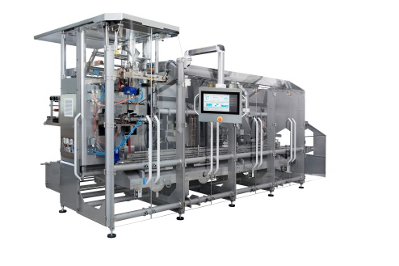
Fig 1: ROVEMA SBS block packing machine for low-dust packing of powdery products
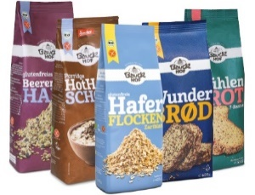
Fig. 2: Gable-top paper bag produced with the Rovema SBS
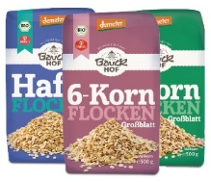.
Fig. 3: Live at Fachpack 2021: flour in a compact bag made of barrier paper. Specially developed for applications in the food industry, SAPPI's Guard Nature 1-MS barrier paper guarantees 100% protection in direct contact with dry foods such as cereals, rice, pasta or flour and can be recycled in the paper waste stream.

Contact:  ROVEMA GmbH  Industriestr.1  35463 Fernwald | Nadja Richter  Marketing & Kommunikation  nadja.richter@rovema.de  Tel. 0641-409-324

