Press release May 2022
Rovema REVO 3800 S produces up to 130 pillow paper bags per minute for the frozen food industry
Mondi and ROVEMA work very successfully together with a high standard of competence within the frozen food industry
Rovema will be exhibiting at Hispack 2022 presenting a sophisticated and sustainable solution for the packaging frozen food. A continuous ROVEMA REVO S machine will be on display: With the REVO series, ROVEMA now has even more to offer to the frozen food industry. The continuous Form Fill and Seal machines of the REVO series have a modular design and are available as a simple version for small budgets up to a special machine with an inclined filling tube for the particularly gentle packaging of fragile products.
Adaptable to continuous or intermittent packaging, the ROVEMA REVO can also reliably process demanding packaging materials such as paper. The ROVEMA REVO is available as standard with Siemens or B&R machine control. At Hispack 2022, ROVEMA will show a pillow bag solution made of kraft paper with water vapour barrier for the deep-freeze industry. A kraft paper from Mondi will be used that can be disposed of via the paper recycling stream.
Mondi's functional barrier papers are a sustainable packaging alternative, especially for FMCG applications, and can be used as a substitute for plastic films and laminates. The application demonstrated at the show achieves an output of up to 130 pillow bags per minute and can be retrofitted to existing REVO S machines.
About the Mondi paper packaging material:
Mondi packaging material is produced from renewable raw materials procured from responsible sources. It is characterised by specific mechanical properties such as puncture resistance, flexibility, printability and protection against external influences. The coating technologies applied to these papers create adapted barriers against grease and water vapour and also ensure sealability.
Paper packaging contributes to a circular economy by maintaining the use of raw materials through recycling. Paper fibres are recycled and reused on average 4 to 6 times; fresh fibres keep the cycle going.
Paper and paper-based packaging are the most recycled material in the EU and worldwide.
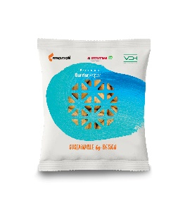
Fig: Packaging solution made of perforated paper as a possible replacement for net packaging, completely manufactured from the flat film web.
Fig: At the Hispack trade fairs in Barcelona, ROVEMA presents Mondi’s Kraftpaper "Functional Barrier 95/5 white Kraft" ; 84 gr/m² with PE coating for frozen food.
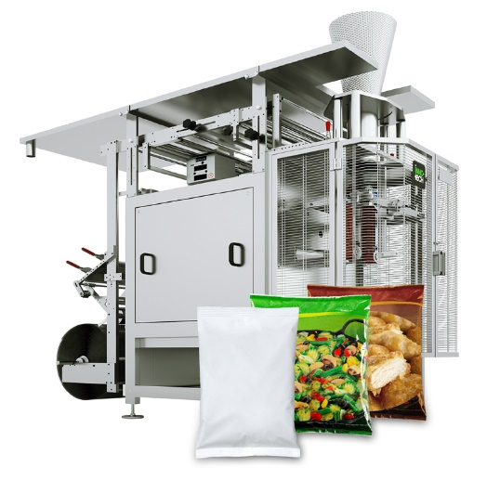
Fig: ROVEMA REVO 3800 for the frozen food industry and for packaging fresh products.

About ROVEMA:
With passion and experience of more than 60 years, ROVEMA develops and builds packaging machines and systems that meet the complex demands of the modern circular economy. ROVEMA thinks holistically and considers the environment, the market, the product and the packaging in projects from the very beginning. This enables the development of efficient and future-proof packaging machines with high availability. A sustainable solution that fits the characteristics of the product to be packaged and its requirements for logistics, packaging material, durability and energy efficiency is ROVEMA's highest priority. A successful concept - ROVEMA has already delivered more than 30,000 machines and systems worldwide.

