ROVEMA takes over DL Packaging BV January 2020

As of 9th January 2020 DL Packaging has become part of the ROVEMA group. DL Packaging is a leading company for retrofit VFFS machines and relevant supplies. The product and service portfolio is flanked by a simple own vertical Form, Fill and Seal machine in the medium price segment. With this acquisition, ROVEMA broadens its range of products in the retrofit and new machine segment gaining further access to customers in the medium price segment . DL Packaging will be part of the business unit Life Cycle Services and will continue to operate from Oosterhout with the existing team and brand name. All DL Packaging employees will keep their previous functions and tasks. Both companies are looking forward to this cooperation and see many advantages and opportunities.
CEO Leo van der Vorm: “DL Packaging proves that since 1996 there is a big European market for well retrofitted machines and medium priced vertical Form, Fill and Seal machines; already approximately 600 DL Packaging machines have been delivered. “
With more than 30.000 machines delivered worldwide, Rovema does have a bigger installed base, but has only been active in the retrofit business since 2014. CEO Ralf Buch: “Through the cooperation with DL packaging, Rovema strengthens its business unit retrofit machines and further invests in a sustainable business model that allows a second usage phase for retrofitted used machines.”

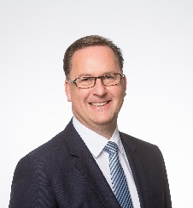
image: CEO Ralf Buch (ROVEMA)

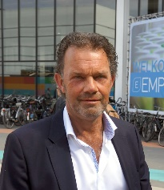
image: CEO Leo van der Vorm (DL Packaging)

Ansprechpartnerin:
ROVEMA GmbH
Industriestr.1
35463 Fernwald
Nadja Richter, Marketing & Kommunikation
nadja.richter@rovema.de
Tel. 0641-409-324

