March 2021

ROVEMA takes over inno-tech and Prins Verpakkingstechniek and Engineering

The ROVEMA family continues to grow! With the acquisitions of inno-tech and Prins Verpakkingstechniek und Engineering (short: Prins) on March 01, ROVEMA strengthens its expertise in stainless steel machinery and new applications and can address new customer groups. In addition, ROVEMA not only gains well-trained specialists, but also additional production space in the immediate vicinity of the main production site in Fernwald. All employees at the sites in Reiskirchen (DE) and Veenendaal (NL) will be taken into the Rovema group.
inno-tech, based in Reiskirchen, Germany, specializes in stainless steel vertical packaging machines for the food industry and technical applications, with Europe as the main market at present . The special focus on frozen food and the production of large pack sizes, e.g. for spices and pet food, makes inno-tech a suitable addition to the ROVEMA product portfolio.
In close cooperation with the experienced inno-tech managing director Sebastian Klein, these strengths will also be further expanded in the ROVEMA network. Klein comments:
"The takeover by ROVEMA and the associated entry into the Haniel Group is a great opportunity for inno-tech to continue growing internationally and offers us more security for the future and an even more long-term orientation."
The production area in Reiskirchen will be used specifically for the manufacture and assembly of stainless steel machines. This enables an optimization of production techniques in the immediate vicinity of the ROVEMA headquarters in Fernwald.

With the acquisition of Prins by ROVEMA Benelux, ROVEMA achieves full market penetration in this sales area. Under the leadership of ROVEMA Benelux Managing Director Christel Geerts, the core business will be complemented with a special focus on sales and service competence.
ROVEMA Managing Director Jens Torkel: "With inno-tech and Prins we can further strengthen our sales and service competence. The know-how of inno-tech in the field of stainless steel machines will support us in our further development, as well as in new markets. The expansion of our portfolio, the additional production area and the well-trained specialists are an important factor for our further growth."

Also, sustainable competence is crucial for long-term business success. For manufacturers of packaging machinery, the increased consumer interest in sustainable packaging solutions offers great opportunities for differentiation. Completely new packaging concepts and the development of new market segments are possible. Vertical packaging in particular offers a variety of approaches to saving resources, such as packaging materials, says Torkel: "Resource-efficient food packaging depends to a large extent on the competence of employees. Opportunities must be recognized in good time and implemented technically. That's why we're looking forward to combining our competencies with inno-tech and Prins and further expanding our network in this way." ROVEMA can already close loops and look after machines for many decades. It is also possible to take back used machines, refurbish them and sell them again.

About ROVEMA GmbH: With passion and the experience of more than 60 years, ROVEMA develops and builds packaging machines and lines that meet the complex demands of the modern circular economy. ROVEMA thinks holistically and considers the environment, the market, the product and the packaging in projects from the very beginning. This enables the development of efficient and sustainable packaging machines with high availability. A sustainable solution that fits the characteristics of the product to be packed and its requirements for logistics, packaging material, shelf life and energy efficiency is a top priority for ROVEMA. A successful concept - ROVEMA has already delivered more than 30,000 machines and lines worldwide. In 2019, ROVEMA generated approximately 100 million euros in sales with more than 600 employees worldwide

About inno-tech (Reiskirchen, Germany):
Since the company was founded in 1992, inno-tech has delivered more than 1500 packaging machines worldwide. The company's strategic focus is on vertical stainless steel packaging machines for the food and non-food sectors. inno-tech currently employs around 60 people.

About Prins Verpakkingstechniek and Engineering (Veenendaal, Netherlands):
Prins Verpakkingstechniek specializes in the distribution of packaging machines and is inno-tech's trading partner for Benelux. The company also offers after-sales services. The associated engineering office Prins Engineering configures customer-specific solutions. Prins employs 11 people at its Veenendaal site.
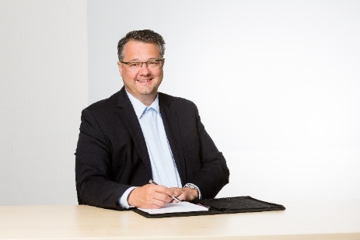
Fig.: ROVEMA Managing Director Jens Torkel.
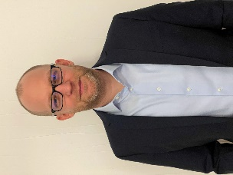
Fig.: Inno-tech Managing Director Mr. Sebastian Klein

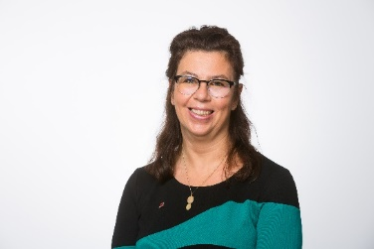
Fig.: Rovema Benelux Managing Director Christel Geerts

Your contact:
ROVEMA GmbH
Industriestr.1
35463 Fernwald
Nadja Richter, Marketing & Kommunikation
nadja.richter@rovema.de
Tel. 0641-409-324

