Press release June 2020

Efficient and sustainable packaging of liquids
ROVEMA BVC 310 Liquid is now available with a fitment option for use in portion dispensers.

Liquid and pasty products or products preserved in oil or vinegar have one thing in common: they are frequently used in the food service sector and must be quickly, efficiently and safely transportable, storable and usable.
ROVEMA as a specialist for flexible vertical packaging has taken up this topic and has further expanded its competence in packaging liquids. The vertically continuous Form Fill and Seal machine BVC 310 Liquid is now available with a fitment option for use in portion dispensers. This hygienic product removal is essential for many system restaurateurs.
Even lumpy products in brine can be packed in low-air pillow bags. This application is also particularly interesting as a replacement for rigid packaging such as buckets or cans. A good advantage of this flexible solution would be lower packaging material volume and weight. This is an important factor in view of the diverse sustainability goals of international companies.

By using flexible, low-air pillow bags, you can optimize your packaging processes and supply chain in a future-proof way - without compromising on product shelf life and quality. This is because Vertical Form Fill and Seal machines can be quickly and flexibly adapted to changing bag lengths, filling quantities and product changes and also have a small footprint.
If you want to learn more about the change from rigid to flexible packaging for liquid products, we recommend our new white paper: https://www.rovema.com/en/engineering/liquid-packaging

ROVEMA - Reduce, reuse, recycle and THINK sustainably.

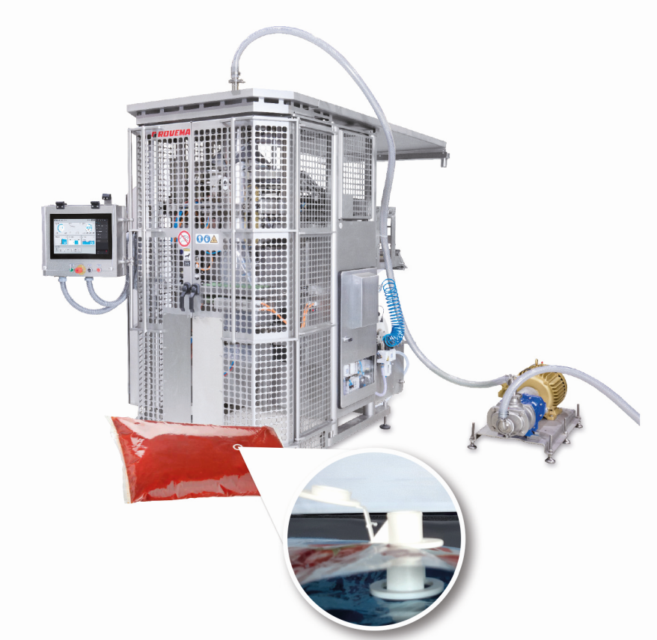

Figure: ROVEMA BVC 310 Liquid for the packaging of liquids. From now on the pillow bags can also be provided with a fitment and thus be used in portion dispensers.

contact:
ROVEMA GmbH
Industriestr.1
35463 Fernwald
Nadja Richter, Marketing & Kommunikation
nadja.richter@rovema.de
Tel. 0641-409-324

